UNIT-2
CPU Scheduling:
CPU scheduling is the process of determining which process or task is to be executed by the central processing unit (CPU) at any given time. It is an important component of modern operating systems that allows multiple processes to run simultaneously on a single processor. The CPU scheduler determines the order and priority in which processes are executed and allocates CPU time accordingly, based on various criteria such as CPU utilization, throughput, turnaround time, waiting time, and response time.

CPU Scheduling Criteria

CPU Utilization

CPU utilization is a criterion used in CPU scheduling that measures the percentage of time the CPU is busy processing a task. It is important to maximize CPU utilization because when the CPU is idle, it is not performing any useful work, and this can lead to wasted system resources and reduced productivity.

2. Throughput

Throughput is a criterion used in CPU scheduling that measures the number of tasks or processes completed within a specific period. It is important to maximize throughput because it reflects the efficiency and productivity of the system.

3. Turnaround Time

Turnaround time is a criterion used in CPU scheduling that measures the time it takes for a task or process to complete from the moment it is submitted to the system until it is fully processed and ready for output. It is important to minimize turnaround time because it reflects the overall efficiency of the system and can affect user satisfaction and productivity.

4. Waiting Time

Waiting time is a criterion used in CPU scheduling that measures the amount of time a task or process waits in the ready queue before it is processed by the CPU. It is important to minimize waiting time because it reflects the efficiency of the scheduling algorithm and affects user satisfaction.

5. Response Time
Response time is a criterion used in CPU scheduling that measures the time it takes for the system to respond to a user's request or input. It is important to minimize response time because it affects user satisfaction and the overall efficiency of the system.

Types of CPU Scheduling

There are mainly two types of CPU scheduling as follows :
- Preemptive
- Non Preemptive

Preemptive Scheduling
- In preemptive scheduling, the operating system has the capability to interrupt a currently running process and temporarily suspend its execution to start or resume another process.
- The decision to switch between processes can occur at any time, typically based on factors like priority or a predefined time quantum.
- Allows for dynamic prioritization based on system conditions.
- Frequent context switches between processes.
Responsive to changes in process states.
- Ex:Shortest Remaining time first(SRTF),Round Robin(RR),Priority Scheduling

Non-Preemptive Scheduling
- In non-preemptive scheduling, a running process cannot be interrupted until it completes its execution or enters a waiting state voluntarily.
- The operating system makes scheduling decisions only when a process terminates or moves to the waiting state.
- Simpler to implement and manage.
- Generally results in longer CPU bursts for running processes.
- Less frequent context switches compared to preemptive scheduling.
- Ex: First Come First Serve (FCFS),Shortest Job First(SJF),Highest Response Ratio Next(HRRN),Multilevel Queue, Priority Scheduling
- Various Times related to the Process
- 1. Arrival Time
- The time at which the process enters into the ready queue is called the arrival time.
- 2. Burst Time
- The total amount of time required by the CPU to execute the whole process is called
- the Burst Time. This does not include the waiting time. It is confusing to calculate the
- execution time for a process even before executing it hence the scheduling problems based on
- the burst time cannot be implemented in reality.
- 3. Completion Time
- The Time at which the process enters into the completion state or the time at which
- the process completes its execution, is called completion time.
- 4. Turnaround time
- The total amount of time spent by the process from its arrival to its completion, is
- called Turnaround time.
- 5. Waiting Time
- The Total amount of time for which the process waits for the CPU to be assigned is
- called waiting time.
- 6. Response Time
- The difference between the arrival time and the time at which the process first gets the
- CPU is called Response Time.
- Scheduling Algorithms in OS (Operating System)
- There are various algorithms which are used by the Operating System to schedule the
- processes on the processor in an efficient way.
- Various Times related to the Process
- 1. Arrival Time
- The time at which the process enters into the ready queue is called the arrival time.
- 2. Burst Time
- The total amount of time required by the CPU to execute the whole process is called
- the Burst Time. This does not include the waiting time. It is confusing to calculate the
- execution time for a process even before executing it hence the scheduling problems based on
- the burst time cannot be implemented in reality.
- 3. Completion Time
- The Time at which the process enters into the completion state or the time at which
- the process completes its execution, is called completion time.
- 4. Turnaround time
- The total amount of time spent by the process from its arrival to its completion, is
- called Turnaround time.
- 5. Waiting Time
- The Total amount of time for which the process waits for the CPU to be assigned is
- called waiting time.
- 6. Response Time
- The difference between the arrival time and the time at which the process first gets the
- CPU is called Response Time.
- Scheduling Algorithms in OS (Operating System)
- There are various algorithms which are used by the Operating System to schedule the
- processes on the processor in an efficient way.
- Various Times related to the Process
- 1. Arrival Time
- The time at which the process enters into the ready queue is called the arrival time.
- 2. Burst Time
- The total amount of time required by the CPU to execute the whole process is called
- the Burst Time. This does not include the waiting time. It is confusing to calculate the
- execution time for a process even before executing it hence the scheduling problems based on
- the burst time cannot be implemented in reality.
- 3. Completion Time
- The Time at which the process enters into the completion state or the time at which
- the process completes its execution, is called completion time.
- 4. Turnaround time
- The total amount of time spent by the process from its arrival to its completion, is
- called Turnaround time.
- 5. Waiting Time
- The Total amount of time for which the process waits for the CPU to be assigned is
- called waiting time.
- 6. Response Time
- The difference between the arrival time and the time at which the process first gets the
- CPU is called Response Time.
- Scheduling Algorithms in OS (Operating System)
- There are various algorithms which are used by the Operating System to schedule the
- processes on the processor in an efficient way.
- Various Times related to the Process
- 1. Arrival Time
- The time at which the process enters into the ready queue is called the arrival time.
- 2. Burst Time
- The total amount of time required by the CPU to execute the whole process is called
- the Burst Time. This does not include the waiting time. It is confusing to calculate the
- execution time for a process even before executing it hence the scheduling problems based on
- the burst time cannot be implemented in reality.
- 3. Completion Time
- The Time at which the process enters into the completion state or the time at which
- the process completes its execution, is called completion time.
- 4. Turnaround time
- The total amount of time spent by the process from its arrival to its completion, is
- called Turnaround time.
- 5. Waiting Time
- The Total amount of time for which the process waits for the CPU to be assigned is
- called waiting time.
- 6. Response Time
- The difference between the arrival time and the time at which the process first gets the
- CPU is called Response Time.
- Scheduling Algorithms in OS (Operating System)
- There are various algorithms which are used by the Operating System to schedule the
- processes on the processor in an efficient way.
- Various Times related to the Process
- 1. Arrival Time
- The time at which the process enters into the ready queue is called the arrival time.
- 2. Burst Time
- The total amount of time required by the CPU to execute the whole process is called
- the Burst Time. This does not include the waiting time. It is confusing to calculate the
- execution time for a process even before executing it hence the scheduling problems based on
- the burst time cannot be implemented in reality.
- 3. Completion Time
- The Time at which the process enters into the completion state or the time at which
- the process completes its execution, is called completion time.
- 4. Turnaround time
- The total amount of time spent by the process from its arrival to its completion, is
- called Turnaround time.
- 5. Waiting Time
- The Total amount of time for which the process waits for the CPU to be assigned is
- called waiting time.
- 6. Response Time
- The difference between the arrival time and the time at which the process first gets the
- CPU is called Response Time.
- Scheduling Algorithms in OS (Operating System)
- There are various algorithms which are used by the Operating System to schedule the
- processes on the processor in an efficient way.
- Various Times related to the Process
- 1. Arrival Time
- The time at which the process enters into the ready queue is called the arrival time.
- 2. Burst Time
- The total amount of time required by the CPU to execute the whole process is called
- the Burst Time. This does not include the waiting time. It is confusing to calculate the
- execution time for a process even before executing it hence the scheduling problems based on
- the burst time cannot be implemented in reality.
- 3. Completion Time
- The Time at which the process enters into the completion state or the time at which
- the process completes its execution, is called completion time.
- 4. Turnaround time
- The total amount of time spent by the process from its arrival to its completion, is
- called Turnaround time.
- 5. Waiting Time
- The Total amount of time for which the process waits for the CPU to be assigned is
- called waiting time.
- 6. Response Time
- The difference between the arrival time and the time at which the process first gets the
- CPU is called Response Time.
- Scheduling Algorithms in OS (Operating System)
- There are various algorithms which are used by the Operating System to schedule the
- processes on the processor in an efficient way.
- Various Times related to the Process
- 1. Arrival Time
- The time at which the process enters into the ready queue is called the arrival time.
- 2. Burst Time
- The total amount of time required by the CPU to execute the whole process is called
- the Burst Time. This does not include the waiting time. It is confusing to calculate the
- execution time for a process even before executing it hence the scheduling problems based on
- the burst time cannot be implemented in reality.
- 3. Completion Time
- The Time at which the process enters into the completion state or the time at which
- the process completes its execution, is called completion time.
- 4. Turnaround time
- The total amount of time spent by the process from its arrival to its completion, is
- called Turnaround time.
- 5. Waiting Time
- The Total amount of time for which the process waits for the CPU to be assigned is
- called waiting time.
- 6. Response Time
- The difference between the arrival time and the time at which the process first gets the
- CPU is called Response Time.
- Scheduling Algorithms in OS (Operating System)
- There are various algorithms which are used by the Operating System to schedule the
- processes on the processor in an efficient way.
- Various Times related to the Process
- 1. Arrival Time
- The time at which the process enters into the ready queue is called the arrival time.
- 2. Burst Time
- The total amount of time required by the CPU to execute the whole process is called
- the Burst Time. This does not include the waiting time. It is confusing to calculate the
- execution time for a process even before executing it hence the scheduling problems based on
- the burst time cannot be implemented in reality.
- 3.
- Various Times related to the Process
- 1. Arrival Time
- The time at which the process enters into the ready queue is called the arrival time.
- 2. Burst Time
- The total amount of time required by the CPU to execute the whole process is called
- the Burst Time. This does not include the waiting time. It is confusing to calculate the
- execution time for a process even before executing it hence the scheduling problems based on
- the burst time cannot be implemented in reality.
- 3.

Various Times related to the Process
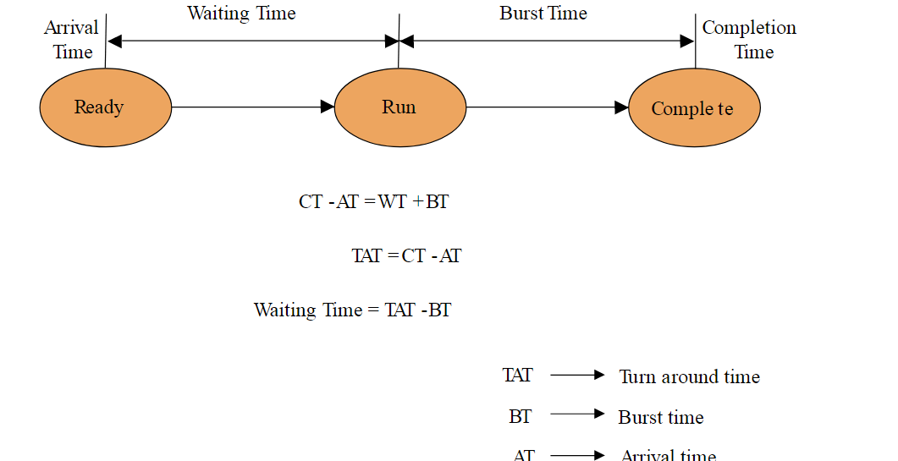

1. Arrival Time
The time at which the process enters into the ready queue is called the arrival time.

2. Burst Time
The total amount of time required by the CPU to execute the whole process is called the Burst Time. This does not include the waiting time. It is confusing to calculate the execution time for a process even before executing it hence the scheduling problems based on the burst time cannot be implemented in reality.

3. Completion Time
The Time at which the process enters into the completion state or the time at which the process completes its execution, is called completion time.

4. Turnaround time
The total amount of time spent by the process from its arrival to its completion, is called Turnaround time.

Turn Around time = Burst time + Waiting time
Or
Turn Around time = Completion time – Arrival time

5. Waiting Time
The Total amount of time for which the process waits for the CPU to be assigned is called waiting time.
Waiting time = Turn Around time – Burst time

6. Response Time
The difference between the arrival time and the time at which the process first gets the CPU is called Response Time.
Response Time = Time at which process first gets the CPU – Arrival time

Scheduling algorithms

A Process Scheduler schedules different processes to be assigned to the CPU based on particular scheduling algorithms. There are six popular process scheduling algorithms as follows

First Come First Serve:
- Jobs are executed on first come, first serve basis.
- It is a non-preemptive, pre-emptive scheduling algorithm.
- Easy to understand and implement.
- Its implementation is based on FIFO queue.
- Poor in performance as average wait time is high.

Problem 1
Consider the given table below and find Completion time (CT), Turn-around time (TAT), Waiting time (WT), Response time (RT), Average Turn-around time and Average Waiting time.
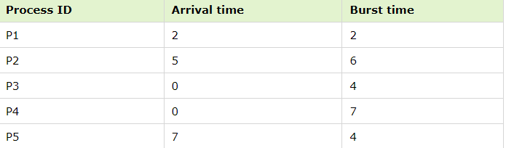

Solution
Gantt chart
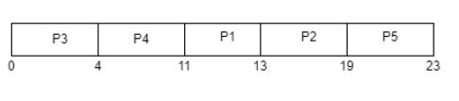
For this problem CT, TAT, WT, RT is shown in the given table –
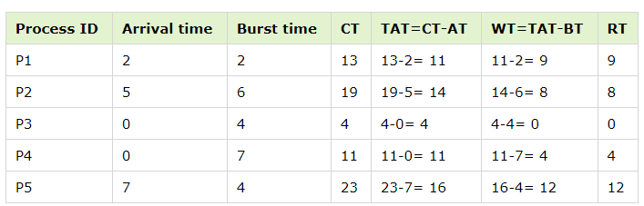
Average Waiting time = (9+8+0+4+12)/5 = 33/5 = 6.6 time unit (time unit can be considered as milliseconds)
Average Turn-around time = (11+14+4+11+16)/5 = 56/5 = 11.2 time unit (time unit can be considered as milliseconds)

Problem 2
Consider the given table below and find Completion time (CT), Turn-around time (TAT), Waiting time (WT), Response time (RT), Average Turn-around time and Average Waiting time.
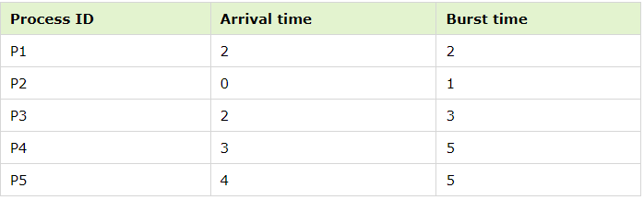

Solution
Gantt chart −
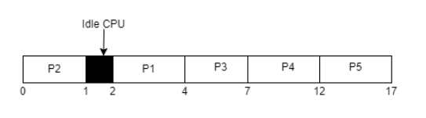
For this problem CT, TAT, WT, RT is shown in the given table –
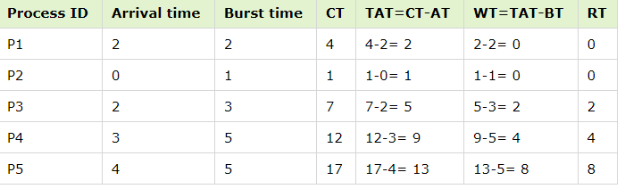
Average Waiting time = (0+0+2+4+8)/5 = 14/5 = 2.8 time unit (time unit can be considered as milliseconds)
Average Turn-around time = (2+1+5+9+13)/5 = 30/5 = 6 time unit (time unit can be considered as milliseconds)
*In idle (not-active) CPU period, no process is scheduled to be terminated so in this time it remains void for a little time.

Shortest Job First:

- SJF allocates CPU to the process with shortest execution time.
- In cases where two or more processes have the same burst time, arbitration is done among these processes on first – come first – serve basis.
- There are both preemptive and non-premptive versions.
- It minimises the average waiting time of the processes.
- It may cause starvation of long processes if short processes continue to come in the system.

Examples of Non-Preemptive SJF Algorithm

Example 1
Suppose that we have a set of four processes that have arrived at the same time in the order P1, P2, P3 and P4. The burst time in milliseconds of each process is given by the following table −
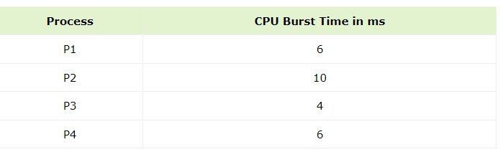
Let us draw the Gantt chart and find the average turnaround time and average waiting time using non-preemptive SJF algorithm.

GANTT chart for the set of processes using SJF
Process P3 has the shortest burst time and so it executes first. Then we find that P1 and P4 have equal burst time of 6ms. Since P1 arrived before, CPU is allocated to P1 and then to P4. Finally P2 executes. Thus the order of execution is P3, P1, P4, P2 and is given by the following GANTT chart –
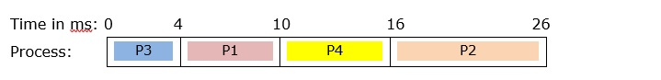
Let us compute the average turnaround time and average waiting time from the above chart.
Average Turnaround Time
=Sum of Turnaround Time of each Process / Number of Processes
= (TAT_{P1} + TAT_{P2} + TAT_{P3} + TAT_{P4}) / 4
= (10 + 26 + 4 + 16) / 4 = 14 ms
Average Waiting Time
= Sum of Waiting Time of Each Process / Number of processes
= (WT_{P1} + WT_{P2} + WT_{P3} + WT_{P4}) / 4
= (4 + 16 + 0 + 10) / 4 = 7.5 ms

Shortest remaining time first:
The Preemptive version of Shortest Job First (SJF) scheduling is known as Shortest Remaining Time First (SRTF). With the help of the SRTF algorithm, the process having the smallest amount of time remaining until completion is selected first to execute.
In the SRTF scheduling algorithm, the execution of any process can be stopped after a certain amount of time. On arrival of every process, the short-term scheduler schedules those processes from the list of available processes & running processes that have the least remaining burst time.

Example of Preemptive SJF (SRTF) algorithm
Let us now perform preemptive SJF (SRTN) scheduling on the following processes, draw GANTT chart and find the average turnaround time and average waiting time.
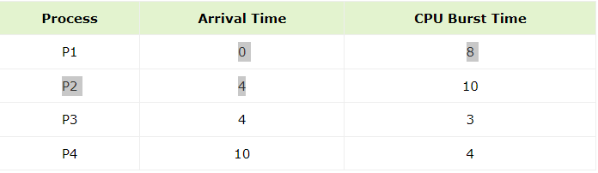

GANTT Chart
Since this is a preemptive scheduling algorithm, the scheduler is invoked when a process arrives and when it completes execution. The scheduler computes the remaining time of completion for each of the processes in the system and selects the process having shortest remaining time left for execution.

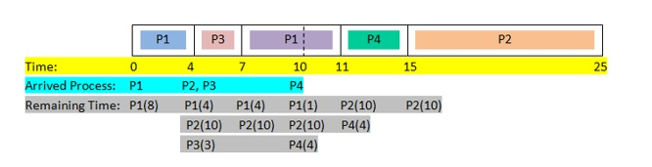
Initially, only P1 arrives and so it is assigned to CPU. At time 4ms, P2 and P3 arrive. The scheduler computes the remaining time of the processes P1, P2 and P3 as 4ms, 10ms and 3ms. Since, P3 has shortest time, P1 is pre-empted by P3. P3 completes execution at 7ms and the scheduler is invoked. Among the processes in the system, P1 has shortest time and so it executes. At time 10ms, P4 arrives and the scheduler again computes the remaining times left for each process. Since the remaining time of P1 is least, no process switch occurs and P1 continues to execute. In the similar fashion, the rest of the processes complete execution.
From the Gantt chart, we compute the average turnaround time and the average waiting time.
Average Turnaround Time
=Sum of Turnaround Time of each Process/ Number of Processes
= (TAT_{P1} + TAT_{P2} + TAT_{P3} + TAT_{P4}) / 4
= ((11 - 0) + (25 - 4) + (7 - 4) + (15 - 10)) / 4 = 10 ms
Average Waiting Time
= Sum of Waiting Time of Each Process/ Number of processes
= (WT_{P1} + WT_{P2} + WT_{P3} + WT_{P4}) / 4
= (3 + 11 + 0 + 1) / 4 = 3.75 ms

Priority based scheduling:

- Priority scheduling is a non-preemptive algorithm and one of the most common scheduling algorithms in batch systems.
- Each process is assigned a priority. Process with highest priority is to be executed first and so on.
- Processes with same priority are executed on first come first served basis.
- The process with the highest priority value is selected for execution.
- Priority can be decided based on memory requirements, time requirements or any other resource requirement.
- There are two variants of Priority scheduling −

Non-preemptive Priority Scheduling
- In the non-preemptive version, once a process is assigned to the CPU, it runs into completion. Here, the scheduler is invoked when a process completes its execution or when a new process(es) arrives in an empty ready queue. The scheduler chooses the process with highest priority for execution.

Preemptive Priority Scheduling
- In the preemptive version, if a high priority process enters the system while a lower priority process is executing, process switch occurs by which the executing process is swapped out while the newly arrived higher priority process starts to execute. Thus the scheduler is invoked either when a new process arrives in the system or an existing process completes its execution.

Examples of Non-Preemptive Priority Scheduling

Example 1
Suppose that we have a set of four processes that have arrived at the same time in the order P1, P2, P3 and P4. The burst time in milliseconds and their priorities of the processes is given by the following table −
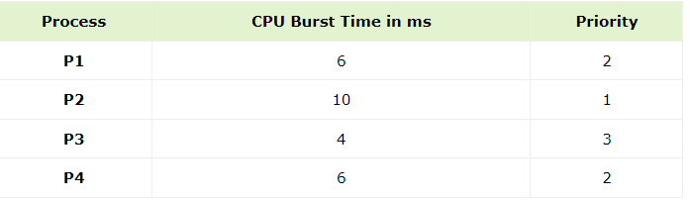
Considering that a lower priority value means higher priority, let us perform non-preemptive priority scheduling on it. We will draw the GANTT chart and find the average turnaround time and average waiting time.

GANTT Chart
Process P2 has the highest priority and so it executes first. Then we find that both P1 and P4 have equal priority value of 2. Since P1 arrived before, CPU is allocated to P1 and then to P4. Finally P3 executes. Thus the order of execution is P2, P1, P4, P3 and is given by the following
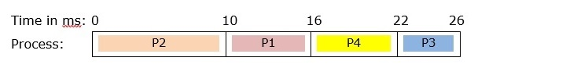
Let us compute the average turnaround time and average waiting time from the above chart.
Average Turnaround Time
= Sum of Turnaround Time of each Process/ Number of Processes
= ( TAT_{P1} + TAT_{P2} + TAT_{P3} + TAT_{P4}) / 4
= ( 16 + 10 + 26 + 22) / 4 = 18.5 ms
Average Waiting Time
= Sum of Waiting Time of Each Process/ Number of processes
= ( WT_{P1} + WT_{P2} + WT_{P3} + WT_{P4}) / 4
= ( 10 + 0 + 22 + 16) / 4 = 10.5 ms

Example of Preemptive Priority Scheduling
In preemptive priority scheduling, if a process arrives that has higher priority than the executing process, then the higher priority process pre-empts the lower priority process. Let us consider the following set of processes whose arrival times, burst times and priorities are give in the following table −
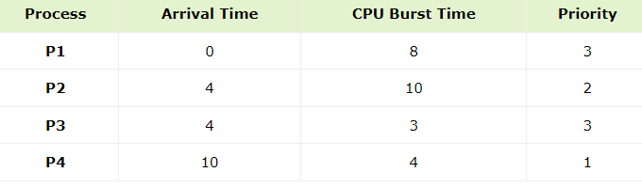

GANTT Chart
At time 0ms, P1 is the only process and so it starts executing. At time 4ms, P2 and P3 arrive. Since P2 has higher priority than P1, P2 preempts P1. At 10ms, P4 arrives which has higher priority than P2 and so pre-empts P2. P4 completes execution at 14ms and leaves. The processes in the system are P1, P2 and P3, among which P2 has highest priority and so is assigned to CPU. At 18ms, P2 completes execution and so P1 and P3 are the processes in the system. Since both processes are of same priority, the scheduler selects P1 by FCFS method. When P1 completes execution, finally P3 executes. The following GANTT chart shows the order of execution −
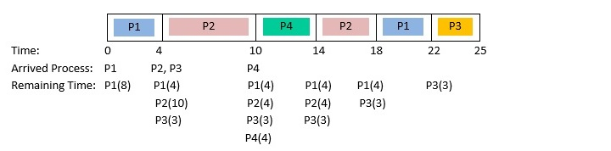
From the GANTT chart, we compute the average turnaround time and the average waiting time.
Average Turnaround Time
= Sum of Turnaround Time of each Process/ Number of Processes
= (TAT_{P1} + TAT_{P2} + TAT_{P3} + TAT_{P4}) / 4
= ((22-0) + (18-4) + (25-4) + (14-10)) / 4 = 15.25 ms
Average Waiting Time
= Sum of Waiting Time of Each Process/ Number of processes
= (WT_{P1} + WT_{P2} + WT_{P3} + WT_{P4}) / 4
= (14 + 4 + 18 +0) / 4 = 7 ms

Round Robin:

- Round Robin is the preemptive process scheduling algorithm.
- Each process is provided a fix time to execute, it is called a quantum.
- Once a process is executed for a given time period, it is preempted and other process executes for a given time period.
- Context switching is used to save states of preempted processes.

Working of Round Robin Scheduling algorithm
- All the given processes enter into the ready queue as per arrival time.
- When the first process goes to the execution state, other processes are in the ready queue and wait for the first process to complete its execution.
- The first process gets executed till the quantum time (preempted), and if it has a remaining burst time then it is sent to the end of the queue.
- If the first process completes its execution with the burst time within the specified quantum time, then the process is terminated by the scheduler.
- This process continues until all the process completes its execution within the time period and the ready queue gets empty.
We will discuss three examples with different arrival times.
Example 1 − Given are the three processes P1, P2, and P3 with different arrival times, and burst time.
Quantum time =2.
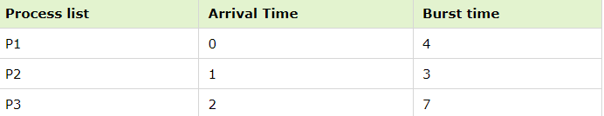
GANTT CHART
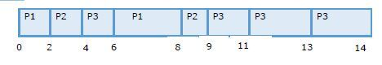
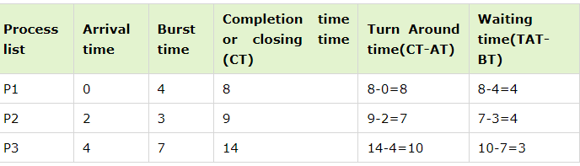
Completion time is the time period of each process when it completes its execution successfully and is taken out of the queue, which can be traced using the Gantt chart provided above.
Average WT = (4+4+3) / 3 = 3.66 units
Average TAT = (8+7+10) / 3 = 8.33 units

6. Multiple-Level Queues Scheduling
In multilevel queue scheduling, the processes are divided into separate categories, where category has its own distinct characteristics. In most systems, there are three types of processes, the system processes, the foreground processes and the background processes.
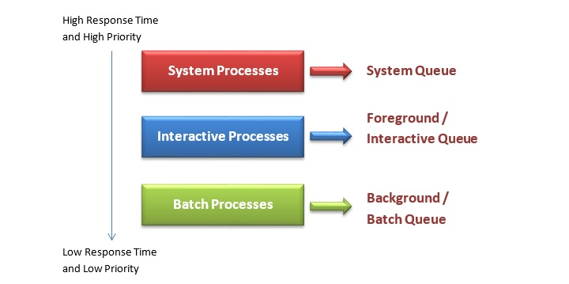

Working Principle of Multilevel Queue (MLQ) Scheduling
The principle of execution is as follows −
Let there be n queues numbered from 1 to n having priorities from 1 to n. Each process is permanently assigned to one of these queues. A queue enjoys absolute priority over the queues having lower priorities. Each queue has its own scheduling strategy. At first, queue 1 with priority 1 is checked. If there are processes in it, they execute according to the scheduling strategy of queue 1.
If there are no processes in it, then queue 2 is checked. If it has processes, then they are scheduled according to its scheduling algorithm. This continues up to queue n. Thus a process in queue x can gain access to CPU only if queue 1 to queue (x-1) are empty. If a process, say P5, at queue x is executing and a new process, say P16, arrives at a queue having higher priority, P16 immediately pre-empts P5 and starts to execute.

Example of Multilevel Queue (MLQ) Scheduling
Let us consider as system with 3 queues having priorities 1 to 3, having processes P1 to P5 as shown in the following table −
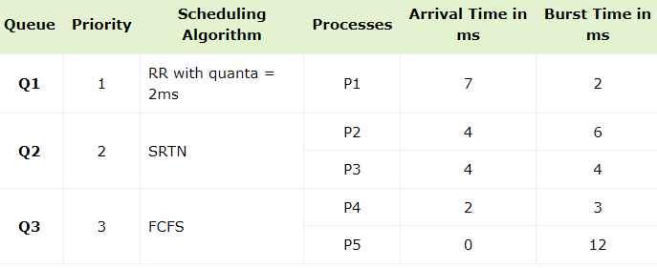
Let us perform MLQ scheduling and draw GNATT chart of the processes.
At Time = 0ms
Event: P5 of Q3 arrives
Processes in the system: P5 in Q3.
Since, P5 is the only process, it is scheduled immediately.
At Time = 2ms
Event: P4 of Q3 arrives
Processes in the system: P4 and P5 in Q3.
Since, both P4 and P5 are in Q3 and Q3 follows First – Come – First - Serve scheduling, P5 continues execution.
GANTT chart up to 2ms is −
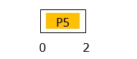
At Time = 4ms
Event: Processes P2 and P3 arrives.
Processes in the system: P2 and P3 in Q2; P4 and P5 in Q3.
Since both P2 and P3 are in Q2 while executing process P5 is in Q3, P5 is pre-empted. Among P2 and P3, P3 is assigned to CPU since Q2 follows Shortest - Remaining – Time - Next scheduling
GANTT chart up to 4ms is −
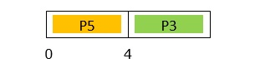
At Time = 7ms
Event: Processes P1 arrives.
Processes in the system: P1 in Q1; P2, P3 in Q2; P4, P5 in Q3.
Since P1 is in Q1 while executing process P3 is in Q2, P3 is pre-empted and P1 starts to execute.
GANTT chart up to 7ms is −
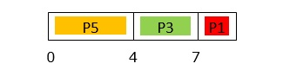
At Time = 9ms
Event: Processes P1 completes execution.
Processes in the system: P2, P3 in Q2; P4, P5 in Q3.
Since P2 and P3 are in Q2 which are at higher priority queue than P4 and P5, they compete for CPU time. P3 is assigned to CPU since Q2 uses SRTN scheduling, and remaining times of P2 and P3 are 6 and 1 respectively.
GANTT chart up to 9ms is −
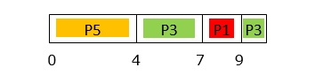
At Time = 10ms
Event: Processes P3 completes execution.
Processes in the system: P2 in Q2; P4, P5 in Q3.
Since P2 is in Q2 which are at higher priority queue than P4 and P5, P2 is assigned to CPU.
GANTT chart up to 10ms is −
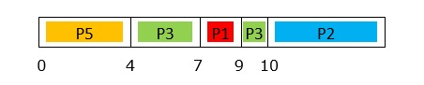
At Time = 16ms
Event: Processes P2 completes execution.
Processes in the system: P4, P5 in Q3.
Since P5 had arrived first and Q3 follows FCFS scheduling, P5 is assigned to CPU.
GANTT chart up to 16ms is −
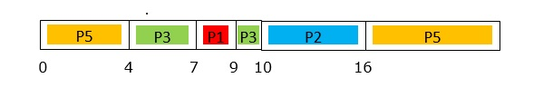
At Time = 24ms
Event: Processes P5 completes execution.
Processes in the system: P4 in Q3.
Since P4 is the only process in system, it is assigned to CPU.
GANTT chart up to 24ms is −
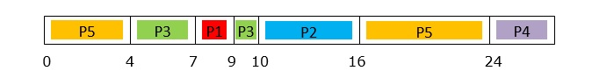
At Time = 27ms
Event: Processes P4 completes execution.
Processes in the system: none
Final GANTT chart up to 27ms is −
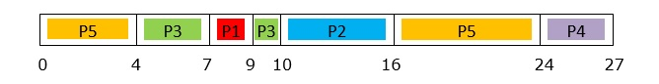

What is Multilevel Feedback Queue Scheduling?
Multilevel Feedback Queue Scheduling CPU scheduling algorithm is almost like Multilevel Queue Scheduling but with an additional feature that enables the switching of processes between queues and thereby overcoming the problem of starvation.

Why Multilevel Feedback Queue Scheduling?
As against Multilevel Queue Scheduling, where processes are restricted from jumping or migrating from one queue to another, here in order to avoid starvation a process can migrate from a queue of lower priority to a queue of higher priority and also from a queue of higher priority to a queue of lower priority due to ageing.

Example of Multilevel Feedback Queue Scheduling
Let us consider a multilevel feedback queue scheduling example where there are three queues, Queue1 containing processes pertaining to system processes, Queue2 containing a set of interactive ready processes and Queue3 with a set of Batch processes.
As shown in the diagram given above, System Processes i.e. Queue1 have the highest priority, next comes Queue2 i.e. a set of interactive processes and finally Queue3 of Batch processes i.e. the one with the least priority.
Suppose, Queue1 has the processes P1, P2, P3, and P4; Queue2 has the processes P5, and P6, Queue3 has the processes P7, and P8.
To understand the Multilevel Feedback Queue Scheduling algorithm let us consider the scenario where the processes P1, P2, P3, and P4 of Queue1 have been executed and it is empty. So, according to priority, the next process to be executed will be Queue2. P5 and P6 also get executed and the queue Queue2 becomes empty.
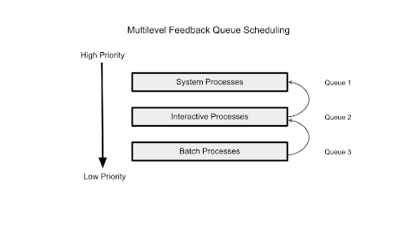
Now, the processes of Queue3 will be assigned to the CPU. Suppose P7 of Queue3 gets the CPU time and is running. In the meantime, a process P9 enters Queue2, since Queue2 has a higher priority than Queue3 the CPU will be preempted to P9. If this type of functioning continues with more processes coming into Queue1 and Queue2, the CPU will continue getting preempted to the new processes and P7 will keep waiting indefinitely leading to starvation. To avoid starvation in the Multilevel Feedback Queue Scheduling we can implement ageing that is increasing the priority of waiting processes by moving them to queues of higher priority. Now, let us move P7 to Queue2 to increase the chances of its execution. But, suppose new processes keep coming in Queue1 and Queue2 and still P7 has not been executed then after reaching its threshold value it can also be moved to Queue1 which has the highest priority thus, executing P7. Thus, the starvation problem gets totally eliminated in a Multilevel Feedback Queue Scheduling by moving processes from queues of lower priority to queues of higher priority.
It is not only moving processes from lower priority to higher priority but also vice versa.
Suppose there are queues which have a fixed execution time for each process. Let us consider a scenario where we again have three different queues with scheduling algorithms of their own. Here in Queue1, each process is assigned a time quantum of 5 units, similarly, Queue2 has a time quantum of 10 units per process and Queue3 that of 15 units per process.
Now, let's say a process P1 with a burst time of 10 units enters the queue with the highest priority i.e. Queue1, here the process can execute for only 5 units of time and then the process will be demoted to Queue2 where the rest of the processing will take place till its completion and for the remaining 10 units of time. Thus, in a Multilevel feedback Queue Scheduling the processes are not only promoted to a queue with higher priority but also demoted to a queue with lower priority as shown in the figure given below.
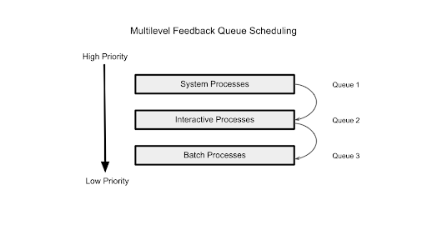

Multiple Processor Scheduling in Operating Systems
Multiple processor scheduling is a technique used in multiprocessor systems where multiple CPUs are available to execute processes. The goal is to efficiently distribute processes among the processors to improve system performance and resource utilization.

Approaches to Multiple-Processor Scheduling
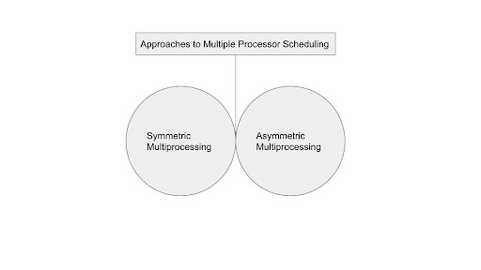

1. Symmetric Multiprocessor
The processors self-schedule in symmetric multiprocessor scheduling. Each processor's scheduler looks through the ready queue before choosing a process to run. Each processor interacts with the others while using the same copy of the operating system. The system continues to function even if one of the CPUs fails.

Symmetrical Scheduling with Global Queues
The scheduler for each processor checks this global-ready queue and chooses a process to execute if the processes to be executed are in a common queue or a global queue.

2. Asymmetric Multiprocessor
A master server and slave servers are both used in asymmetric multiprocessor scheduling. All scheduling and I/O operations are handled by the master server, while user processes are handled by the slave servers. The entire system shuts down if the master server fails. The system continues to function even if one of the slave servers fails.

Load Balancing
For a symmetric multiple processor system to benefit from having several processors, each CPU must have an equal workload. It could happen that certain processors in the system wind up being idle while others have heavy workloads along with the programmes that are waiting in the CPU if the workload is not evenly distributed among all the system's processors.

Processor Affinity
A process has an affinity for the processor on which it is now operating if it has processor affinity. There are specific effects on the cache memory when a process executes on a certain CPU. The procedure fills the processor's cache with the data it most recently accessed. As a result, the process frequently finds the answers to its subsequent memory requests in the cache memory.
System call interface for process management:
System call provides an interface between user program and operating system.

System calls for Process management
A system is used to create a new process or a duplicate process called a fork.
The duplicate process consists of all data in the file description and registers common. The original process is also called the parent process and the duplicate is called the child process.
The fork call returns a value, which is zero in the child and equal to the child’s PID (Process Identifier) in the parent. The system calls like exit would request the services for terminating a process.
Loading of programs or changing of the original image with duplicate needs execution of exec. Pid would help to distinguish between child and parent processes.

Example
Process management system calls in Linux.
- fork − For creating a duplicate process from the parent process.
- wait − Processes are supposed to wait for other processes to complete their work.
- exec − Loads the selected program into the memory.
- exit − Terminates the process.
The pictorial representation of process management system calls is as follows –
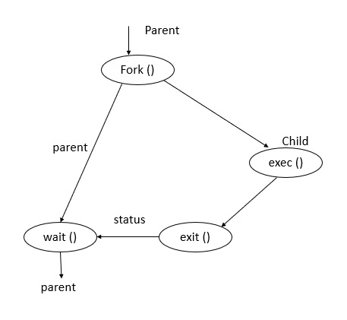
Fork () − A parent process always uses a fork for creating a new child process. The child process is generally called a copy of the parent. After execution of fork, both parent and child execute the same program in separate processes.
Exec () − This function is used to replace the program executed by a process. The child sometimes may use exec after a fork for replacing the process memory space with a new program executable making the child execute a different program than the parent.
Exit () − This function is used to terminate the process.

Wait () − The parent uses a wait function to suspend execution till a child terminates. Using wait the parent can obtain the exit status of a terminated child.
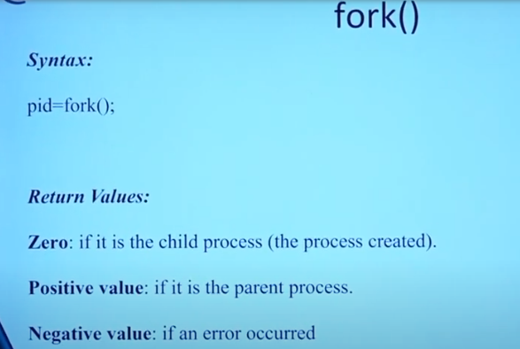
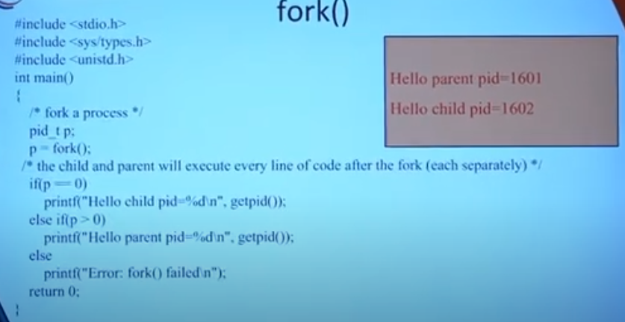
Deadlocks: A deadlock happens in operating system when two or more processes need some resource to complete their execution that is held by the other process.
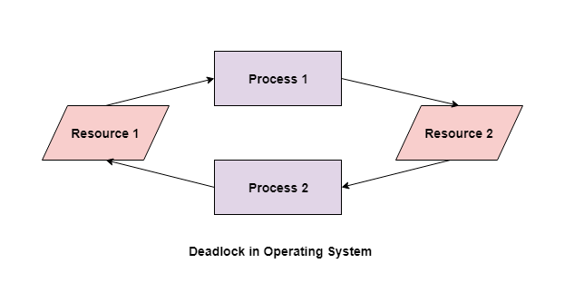
In the above diagram, the process 1 has resource 1 and needs to acquire resource 2. Similarly process 2 has resource 2 and needs to acquire resource 1. Process 1 and process 2 are in deadlock as each of them needs the other’s resource to complete their execution but neither of them is willing to relinquish their resources.

Difference between Starvation and Deadlock
1 |  |  | Deadlock is a situation where no |  |  | Starvation is a situation where the
 |  |  | process got blocked and no process proceeds |  |  | low priority process got blocked and the high priority processes proceed.
2 |  |  | Deadlock is an infinite waiting. |  |  | Starvation is a long waiting but not infinite.
3 |  |  | Every Deadlock is always a starvation. |  |  | Every starvation need not be deadlock.
4 |  |  | The requested resource is blocked by the other process. |  |  | The requested resource is continuously be used by the higher priority processes.
5 |  |  | Deadlock happens when Mutual exclusion, hold and wait, No preemption and circular wait occurs simultaneously. |  |  | It occurs due to the uncontrolled priority and resource management.

Deadlock System Model

In a computer system a deadlock is where two or more processes are unable to proceed because each process is waiting for the other to release a resource that it needs to continue execution. In other words, a deadlock occurs when two or more processes are in a circular wait state, and none of them can release the resources they hold until they receive the resources they are waiting for.
Deadlock System Model − The Deadlock System model is a way to describe and analyze systems that may be prone to deadlocks, which occur when two or more processes are unable to proceed because they are each waiting for the other to release a resource. Below are the components of this model −
- Resources − The system has a set of resources that are shared among processes. These resources can be hardware or software components, such as memory, files, printers, or network connections. Each resource is identified by a unique name or identifier.
- Processes − The system has a set of processes that request and release resources. Processes are units of execution that can be started, suspended, resumed, and terminated. Each process is identified by a unique process ID.
- Resource Allocation − Each resource can be in one of two states , allocated or available. A resource that is allocated to a process cannot be used by any other process until it is released.
- Request and Release − A process can request a resource by sending a request to the system. If the resource is available, it will be allocated to the process. When a process is finished using a resource, it must release it so that it can be used by other processes.
Dead locks Characterization:

i.Necessary Conditions for Deadlock:
These four conditions must be met for a deadlock to happen in an operating system.
1.Mutual Exclusion:

There should be a resource that can only be held by one process at a time. In the diagram below, there is a single instance of Resource 1 and it is held by Process 1 only.

2.Hold and Wait
A process can hold multiple resources and still request more resources from other processes which are holding them. In the diagram given below, Process 2 holds Resource 2 and Resource 3 and is requesting the Resource 1 which is held by Process 1.
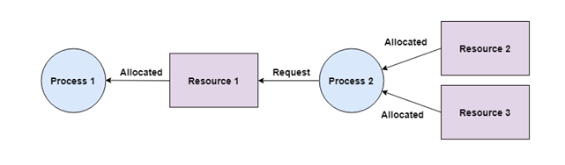
3. No Preemption

A resource cannot be preempted from a process by force. A process can only release a resource voluntarily. In the diagram below, Process 2 cannot preempt Resource 1 from Process 1. It will only be released when Process 1 relinquishes it voluntarily after its execution is complete.
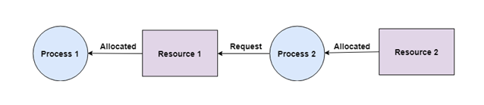
4. Circular Wait

A process is waiting for the resource held by the second process, which is waiting for the resource held by the third process and so on, till the last process is waiting for a resource held by the first process. This forms a circular chain. For example: Process 1 is allocated Resource2 and it is requesting Resource 1. Similarly, Process 2 is allocated Resource 1 and it is requesting Resource 2. This forms a circular wait loop.
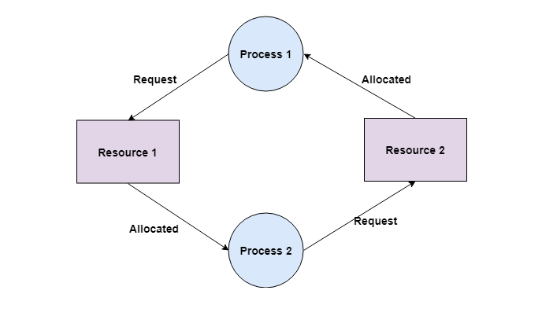
ii) Resource Allocation Graph:
- In some cases deadlocks can be understood more clearly through the use of Resource-Allocation Graphs, having the following properties:
  - A set of resource categories, { R1, R2, R3, . . ., RN }, which appear as square nodes on the graph. Dots inside the resource nodes indicate specific instances of the resource. ( E.g. two dots might represent two laser printers. )
  - A set of processes, { P1, P2, P3, . . ., PN }
  - Request Edges - A set of directed arcs from Pi to Rj, indicating that process Pi has requested Rj, and is currently waiting for that resource to become available.
  - Assignment Edges - A set of directed arcs from Rj to Pi indicating that resource Rj has been allocated to process Pi, and that Pi is currently holding resource Rj.
  - Note that a request edge can be converted into an assignment edge by reversing the direction of the arc when the request is granted. ( However note also that request edges point to the category box, whereas assignment edges emanate from a particular instance dot within the box. )
  - For example:
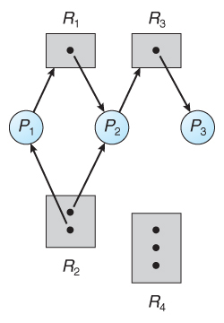
Figure 7.1 - Resource allocation graph-no cycle, no dead lock
- If a resource-allocation graph contains no cycles, then the system is not deadlocked. (When looking for cycles, remember that these are directed graphs.) See the example in Figure 7.1 above.
- If a resource-allocation graph does contain cycles AND each resource category contains only a single instance, then a deadlock exists.
- If a resource category contains more than one instance, then the presence of a cycle in the resource-allocation graph indicates the possibility of a deadlock, but does not guarantee one. Consider, for example, Figures 7.2 and 7.3 below:
To illustrate this concept, we return to the resource allocation graph depicted above fig. Suppose that process p3 requests an instance of resource type R2.since no resource instance is currently available a request edge p3-R2 is added to the graph.
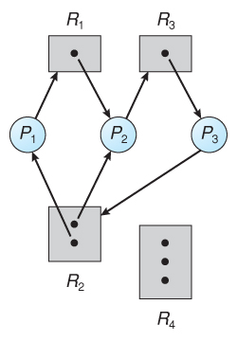
Figure 7.2 - Resource allocation graph with a deadlock
Processes p1, p2, p3 are deadlocked. Process p2 is waiting for the resource R3, which is held by process P3.process p3 is waiting for either process p1 or process p2 to release resource R2.In addition. Process p1 is waiting for process p2 to release resource R1.
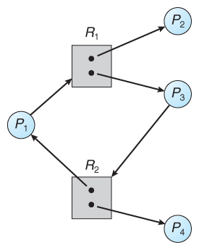
Figure 7.3 - Resource allocation graph with a cycle but no deadlock
In the above fig also have a cycle.However, there is no deadlock, observe that process P4 may release its instance of resource type R2 that resource can then be allocated to P3, breaking the cycle
Summary:
1. If a resource –allocation graph does not have a cycle then a system is not in a deadlocked state.
2. If there is acycle, then the system may or may not be in a deadlocked state.
i) If there is a cycle & if all the resource type contains single instances then deadlock must occurred.
ii) If there is a cycle, if all the resource type contains multiple instances then deadlock may/may not occurred.
Methods for Handling DeadLock:
Deadlock is a situation where a process or a set of processes is blocked, waiting for some other resource that is held by some other waiting process. It is an undesirable state of the system.
There are four main methods for handling deadlocks:
1.Deadlock Prevention:
- Elimination of “Mutual Exclusion” Condition
The mutual exclusion condition must hold for non-sharable resources. That is, several processes cannot simultaneously share a single resource. This condition is difficult to eliminate because some resources, such as the tap drive and printer, are inherently non-shareable. Note that shareable resources like read-only-file do not require mutually exclusive access and thus cannot be involved in deadlock.

- Elimination of “Hold and Wait” Condition
There are two possibilities for elimination of the second condition. The first alternative is that a process request be granted all of the resources it needs at once, prior to execution. The second alternative is to disallow a process from requesting resources whenever it has previously allocated resources. This strategy requires that all of the resources a process will need must be requested at once. The system must grant resources on “all or none” basis. If the complete set of resources needed by a process is not currently available, then the process must wait until the complete set is available. While the process waits, however, it may not hold any resources. Thus the “wait for” condition is denied and deadlocks simply cannot occur. This strategy can lead to serious waste of resources. For example, a program requiring ten tap drives must request and receive all ten derives before it begins executing. If the program needs only one tap drive to begin execution and then does not need the remaining tap drives for several hours. Then substantial computer resources (9 tape drives) will sit idle for several hours. This strategy can cause indefinite postponement (starvation). Since not all the required resources may become available at once.

- Elimination of “No-preemption” Condition
The nonpreemption condition can be alleviated by forcing a process waiting for a resource that cannot immediately be allocated to relinquish all of its currently held resources, so that other processes may use them to finish. Suppose a system does allow processes to hold resources while requesting additional resources. Consider what happens when a request cannot be satisfied. A process holds resources a second process may need in order to proceed while second process may hold the resources needed by the first process. This is a deadlock. This strategy require that when a process that is holding some resources is denied a request for additional resources. The process must release its held resources and, if necessary, request them again together with additional resources. Implementation of this strategy denies the “no-preemptive” condition effectively.
High Cost When a process release resources the process may lose all its work to that point. One serious consequence of this strategy is the possibility of indefinite postponement (starvation). A process might be held off indefinitely as it repeatedly requests and releases the same resources.

- Elimination of “Circular Wait” Condition
The last condition, the circular wait, can be denied by imposing a total ordering on all of the resource types and than forcing, all processes to request the resources in order (increasing or decreasing). This strategy impose a total ordering of all resources types, and to require that each process requests resources in a numerical order (increasing or decreasing) of enumeration. With this rule, the resource allocation graph can never have a cycle.
For example, provide a global numbering of all the resources, as shown

1 | ≡ | Card reader
2 | ≡ | Printer
3 | ≡ | Plotter
4 | ≡ | Tape drive
5 | ≡ | Card punch
Now the rule is this: processes can request resources whenever they want to, but all requests must be made in numerical order. A process may request first printer and then a tape drive (order: 2, 4), but it may not request first a plotter and then a printer (order: 3, 2). The problem with this strategy is that it may be impossible to find an ordering that satisfies everyone.

2. Deadlock Avoidance:

Deadlock Avoidance is a process used by the Operating System to avoid Deadlock.
The general idea behind deadlock avoidance is to prevent deadlocks from ever happening, by preventing at least one of the above conditions.

Safe State and Unsafe State
A safe state refers to a system state where the allocation of resources to each process ensures the avoidance of deadlock. The successful execution of all processes is achievable, and the likelihood of a deadlock is low. The system attains a safe state when a suitable sequence of resource allocation enables the successful completion of all processes.
Conversely, an unsafe state implies a system state where a deadlock may occur. The successful completion of all processes is not assured, and the risk of deadlock is high. The system is insecure when no sequence of resource allocation ensures the successful execution of all processes.
Deadlock Avoidance can be solved by two different algorithms:
- Resource allocation Graph
- Banker’s Algorithm

Resource Allocation Graph
- If resource categories have only single instances of their resources, then deadlock states can be detected by cycles in the resource-allocation graphs.
- In this case, unsafe states can be recognised and avoided by augmenting the resource-allocation graph with claim edges, noted by dashed lines, which point from a process to a resource that it may request in the future.
- In order for this technique to work, all claim edges must be added to the graph for any particular process before that process is allowed to request any resources. ( Alternatively, processes may only make requests for resources for which they have already established claim edges, and claim edges cannot be added to any process that is currently holding resources.)
- When a process makes a request, the claim edge Pi->Rj is converted to a request edge. Similarly when a resource is released, the assignment reverts back to a claim edge.
- This approach works by denying requests that would produce cycles in the resource-allocation graph.
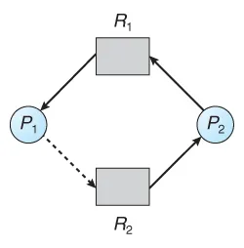An unsafe state in a resource allocation graph
- Banker’s Algorithm:
The Bankers Algorithm in OS is an algorithm used to manage and allocate resources in a multi-task environment. It is used to prevent deadlocks and ensure the system remains in a safe state. The algorithm works by keeping track of the available resources in the system and allocating them to processes in a way that ensures that the system will not run out of resources and enter a deadlock state.

Steps of the Resource Request Algorithm:
1. Check if the Request is within the Process's Maximum Claim:
At every request of resources done by a process P[i], the algorithm checks if the number of resources requested is less than or equal to the Need of that process:
- If Request[i]≤Need[i](for all resources)
If the condition holds, then it proceeds to the next one. Otherwise, process P[i] has exceeded its maximum claim; the request is denied.
If the process exceeds its maximum claim, this is then a violation of the rules of the system; the process cannot be allowed to proceed.
2. Check if the Requested Resources are Available:
The system now checks the availability of the requested resources in sufficient quantity. This is done by comparing the request [i] with the Available resources:
- If Request[i]≤Available(for all resources)
If this condition is satisfied, proceed to the next step. If not, then P[i] must wait until the required resources become available.
This makes sure the system does not allocate resources it does not currently have, which otherwise could lead to deadlock or unsafe states.
3. Simulate Resource Allocation:
If available, the system allocates temporary requested resources to process P[i] by modifying the Available, Allocation, and Need matrices.
- Available=Available−Request[i]
- Allocation[i]=Allocation[i]+Request[i]
- Need[i]=Need[i]−Request[i]
4. Check System Safety:
- After the allocation of the requested resources, the system runs the Safety Algorithm to check whether the system continues to be in a safe state after that allocation.
- The resources are permanently allocated if the system is in a safe state to process P[i].
- Suppose the system is entering an unsafe state. In that case, process P[i] must wait, and the system must roll back to its earlier state by recovering its original values of Available, Allocation, and Need matrices.
Example: Consider a system that contains five processes P1, P2, P3, P4, P5 and the three resource types A, B and C. Following are the resources types: A has 10, B has 5 and the resource type C has 7 instances.
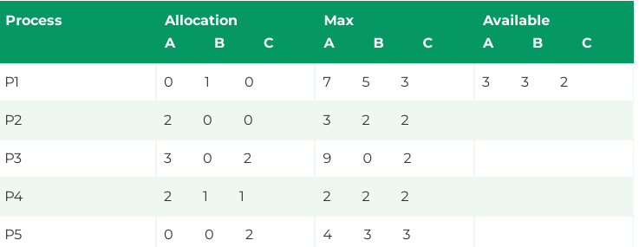
Answer the following questions using the banker's algorithm:
- What is the reference of the need matrix?
- Determine if the system is safe or not.
- Ans. 1: The context of the need matrix is as follows:
- Need[i]=Max[i]-Allocation[i]
Need for P1: (7, 5, 3) - (0, 1, 0) = 7, 4, 3
Need for P2: (3, 2, 2) - (2, 0, 0) = 1, 2, 2
Need for P3: (9, 0, 2) - (3, 0, 2) = 6, 0, 0
Need for P4: (2, 2, 2) - (2, 1, 1) = 0, 1, 1
Need for P5: (4, 3, 3) - (0, 0, 2) = 4, 3, 1
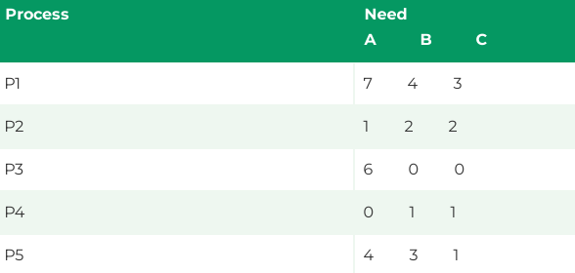
Hence, we created the context of need matrix.
Ans. 2: Apply the Banker's Algorithm:
Available Resources of A, B and C are 3, 3, and 2.
Now we check if each type of resource request is available for each process.
Step 1: For Process P1:
Need <= Available
7, 4, 3 <= 3, 3, 2 condition is false.
So, we examine another process, P2.
Step 2: For Process P2:
Need <= Available
1, 2, 2 <= 3, 3, 2 condition true
New available = available + Allocation
(3, 3, 2) + (2, 0, 0) => 5, 3, 2
Similarly, we examine another process P3.
Step 3: For Process P3:
P3 Need <= Available
6, 0, 0 < = 5, 3, 2 condition is false.
Similarly, we examine another process, P4.
Step 4: For Process P4:
P4 Need <= Available
0, 1, 1 <= 5, 3, 2 condition is true
New Available resource = Available + Allocation
5, 3, 2 + 2, 1, 1 => 7, 4, 3
Similarly, we examine another process P5.
Step 5: For Process P5:
P5 Need <= Available
4, 3, 1 <= 7, 4, 3 condition is true
New available resource = Available + Allocation
7, 4, 3 + 0, 0, 2 => 7, 4, 5
Now, we again examine each type of resource request for processes P1 and P3.
Step 6: For Process P1:
P1 Need <= Available
7, 4, 3 <= 7, 4, 5 condition is true
New Available Resource = Available + Allocation
7, 4, 5 + 0, 1, 0 => 7, 5, 5
So, we examine another process P2.
Step 7: For Process P3:
P3 Need <= Available
6, 0, 0 <= 7, 5, 5 condition is true
New Available Resource = Available + Allocation
7, 5, 5 + 3, 0, 2 => 10, 5, 7
Hence, we execute the banker's algorithm to find the safe state and the safe sequence like P2, P4, P5, P1 and P3.
Deadlock Detection :
The first method detects deadlocks when there is only one instance of each resource type. This method uses a variant of the resource-allocation graph. The second method detects deadlocks even when there are multiple instances of each resource type. The second method uses a variant of the banker’s algorithm.
Deadlock Detection – Single Instance of Each Resource Type:
The system maintains a wait-for graph for detecting deadlocks. The wait-for graph is a variant of the resource-allocation graph. In the wait-for graph, the nodes are processes. If there is an edge Pi ® Pj, then it means that process Pi is waiting for process Pj. The corresponding resource-allocation graph would have had edges Pi ® Rq and Rq ® Pj which means that Pi is waiting for resource Rq and Rq is held by resource Pj. In the wait-for graph, the resource node is removed and there is an edge from Pi ® Pj. Figure 19.1 shows a resource-allocation graph and the corresponding wait-for graph.

To detect deadlocks from the wait-for graph, it is required to periodically invoke an algorithm that searches for a cycle in the wait-for graph. If there is a cycle in the wait-for graph, then it means that there is a deadlock in the system. If there are no cycles, then it means that there is no deadlock in the system. In the wait-for graph shown in Figure 19.1, there is a cycle P1®P2®P3®P4®P1. Hence, the system is in a deadlocked state. An algorithm to detect a cycle in a graph requires an order of n2 operations, where n is the number of vertices in the graph.
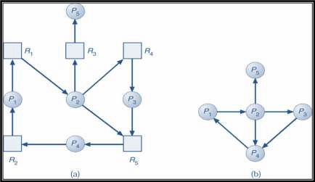
Deadlock Detection – Several Instances of a Resource Type (Bankers Algorithm

In this subsection we learn a deadlock detection algorithm that will detect deadlocks when there are multiple instances of each resource type.

Detection Algorithm

1. Let Work and Finish be vectors of length m and n, respectively. Initialize:
(a) Work = Available
(b) For i = 1,2, …, n, if Allocationi ¹ 0, then Finish[i] = false; otherwise,
Finish[i] = true.

2. Find an index i such that both:
(a) Finish[i] = false
(b) Requesti £ Work
If no such i exists, go to step 4.

3. Work = Work + Allocationi
Finish[i] = true
go to step 2.

4. If Finish[i] == false, for some i, 1 £ i £ n, then the system is in deadlock state.

Moreover, if Finish[i] == false, then Pi is deadlocked.

This algorithm requires an order of O(m x n2) operations to detect whether the system is in deadlocked state. The working of this algorithm can be understood by an example.

Example of Detection Algorithm

Consider 5 processes P0 through P4; 3 resource types A, B and C. There are 7 instances of A, 2 instances of B and 6 instances of C.

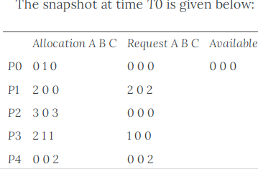
We now simulate the algorithm for the above example.
Initially, Available = (0,0,0); Finish[i] = false for i = 0,1,2,3,4
i = 0
We check if Request0 ≤ Available? Yes
Therefore, Work = Work + Allocation0 =(0,0,0) + (0,1,0) = (0,1,0)
Finish[0] = true , P0 added to safe sequence < P0>
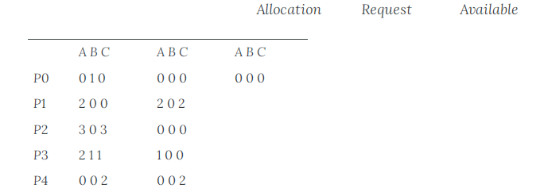
Work = (0,1,0);
Is Request1 ≤ Available? No
Since Request1 is not less than Available, check the next process.

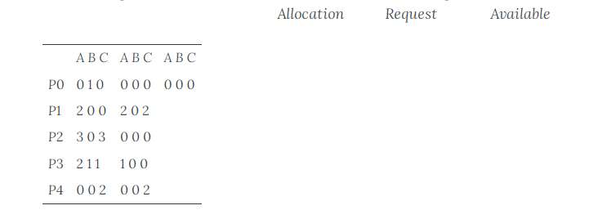
Work = (0,1,0);
Is Request2 ≤ Available? Yes
Work = Work + Allocation2 =(0,1,0) + (3,0,3) = (3,1,3) Finish[2] = true , P2 added to safe sequence < P0, P2>
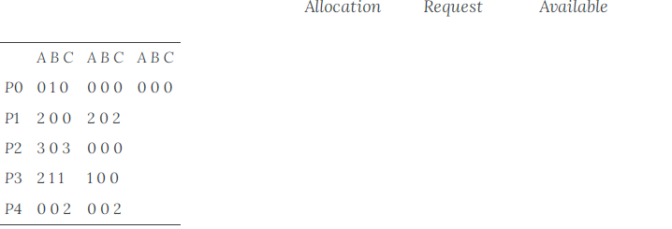
Work = (3,1,3);
Is Request3 ≤ Available? Yes
Work = Work + Allocation3 =(3,1,3) + (2,1,1) = (5,2,4) Finish[3] = true,
P3 added to safe sequence and the safe sequence is now < P0, P2, P3 >
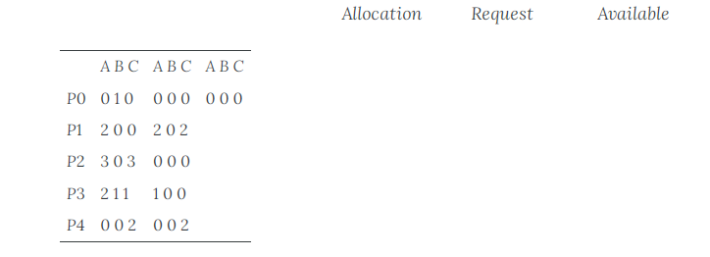

Work = (5,2,4);
Is Request4 ≤ Available? Yes
Work = Work + Allocation4 =(5,2,4) + (0,0,2) = (5,2,6) Finish[4] = true,
P4 added to safe sequence and the safe sequence is < P0, P2, P3, P4 >

Now, we check again from the beginning all the other processes that were not added to the safe sequence.
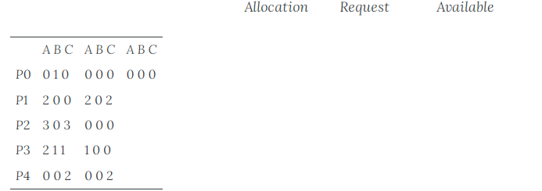

Work = (5,2,6);
Is Request1 ≤ Available? Yes
Work = Work + Allocation1 =(5,2,6) + (2,0,0) = (7,2,6) Finish[1] = true,
P1 added to safe sequence and the safe sequence now is < P0, P2, P3, P4, P1 >
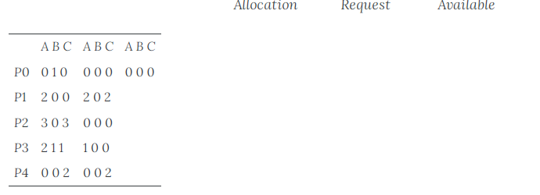

Sequence <P0, P2, P3, P4, P1> now results in Finish[i] = true for all i.

There can be more than one safe sequence, that is there can be correct safe sequences other than <P0, P2, P3, P1, P4>. We have found one safe sequence. Since there is at least one safe sequence, the system is in a safe state. There is no deadlock in the system.

Recovery from Deadlocks

Once deadlocks are detected, it is necessary to recover from deadlocks. There are different ways in which the system can recover from deadlocks. One method is to inform the operator that a deadlock has occurred. The operator deals with the deadlock manually. The second method is to let the system recover from the deadlock automatically. The third method is to break the deadlock. To break the deadlock, there are two ways. One is to abort one or more processes to break the circular wait (process termination). The second is to preempt some resources from one or more of the deadlocked processes (resource preemption).

Recovery from Deadlock:
Once the deadlock is detected then how we can Recover from the deadlock for that there are 2 Approaches
1. Process Termination

Termination of processes can be done in two ways. One is to abort all the deadlocked processes. This method will break the deadlock, but the results of all partial computations done by the aborted processes must be discarded and recomputed later. The second way is to abort one process at a time until the deadlock cycle is eliminated. This method involves a lot of overhead, because, after each process is aborted, deadlock-detection algorithm must be invoked to check if the deadlock still exists.

When there are many processes involved in the deadlock, it is necessary to choose a process to terminate first. In which order should we choose a process to abort? There are many factors based on which the process to be aborted can be chosen:

– Priority of the process (process with the least priority is chosen)
– How long process has computed, and how much longer to completion (the process that has done the least computations is chosen)
– Resources the process has used (the process that has used less number of resources is chosen)
– Resources process needs to complete (the process that needs many resources is chosen)
– How many processes will need to be terminated
– Is process interactive or batch? (batch processes are chosen to be terminated earlier than interactive processes)

2.Resource Preemption

To recover from deadlocks, resources can be preempted from the deadlocked processes. When resources are preempted, it is necessary to consider certain issues. The issues are discussed below:
- Selecting a victim

It is necessary to select the victim process from which the resources are to be preempted. The victim process has to be selected such that the cost is minimized. Cost factors may include the number of resources a deadlock process is holding and the amount of time a deadlocked process has thus far consumed during its execution.
- Rollback

If a resource is preempted from a process, what to do with the process? The process cannot continue, because it is missing some needed resource. Therefore, the process must be rolled back to some safe state and the process must be restarted from that state. But, the problem is that it is difficult to determine a safe state. Therefore a total rollback might have to be done or the process must be aborted and restarted again.
- Starvation

While selecting a process for preempting resources, the same process may always be picked as victim. In that case, that process may be starved of resources and may not be able to complete its work. To reduce starvation, the number of rollbacks may also be included in the cost factor.

